SUBJECT: Ordinance 1897, series 2025 – An ordinance amending title 17 of the LOUISVILLE MUNICIPAL CODE (LMC) TO UPDATE PARKING MINIMUMS FOR MULTIFAMILY AND ADAPTIVE REUSE DEVELOPMENT TO COMPLY WITH COLORADO HB24-1304 (continued from July 8, 2025)

DATE: August 5, 2025

Prepared By: MATT POST, AICP, SENIOR PLANNER

Presented By: MATT POST, AICP, SENIOR PLANNER

SUMMARY:
Attached is the proposed ordinance prepared to comply with Colorado House Bill 24-1304. This legislation requires jurisdictions within Metropolitan Planning Organizations (MPOs) to eliminate minimum parking requirements for multifamily and residential adaptive reuse developments located within designated Applicable Transit Service Areas (ATSAs). The City of Louisville is located within the Denver Regional Council of Governments MPO and includes 44 transit stops that qualify as ATSAs. To align with these requirements, staff has proposed amendments to Title 17 of the Louisville Municipal Code (LMC) to remove minimum parking standards for applicable uses within identified ATSAs. City Council continued this item from the July 8, 2025 meeting to allow for further consideration and requested ordinance amendments.

BACKGROUND / PRIOR DISCUSSIONS:
At the July 8 meeting, City Council requested a citywide elimination of minimum parking requirements for multifamily and multi-unit developments, and adaptive reuse developments where fifty percent (50%) or more of floor area is dedicated to residential use. During deliberation, the Council expressed agreement to expand the ordinance beyond the state-mandated ATSAs. This direction reflects the Council’s broader policy goals to support housing affordability, and more flexible land use regulations citywide.

Attachment 2 includes the July 8, 2025 City Council staff report and packet, which contains additional background and analysis, including a summary of HB 24-1304.

PROPSAL:
The revised ordinance (Attachment 1) addresses City Council’s requested changes from the July 8 meeting, which includes the citywide elimination of minimum parking requirements for multifamily and multi-unit developments, and adaptive reuse developments where fifty percent (50%) or more of floor area is dedicated to residential use. Updates to the ordinance include:

- Removal of references limiting the elimination of parking minimums to Applicable Transit Service Areas (ATSAs).
- Elimination of all minimum parking requirements for residential uses in the Downtown zoning district. As multi-unit dwellings are the only permitted residential type in this district, this update effectively removes all residential parking minimums downtown.

ANALYSIS:
The City’s Housing Plan identifies minimum parking requirements as a constraint to meeting current and future housing needs, particularly for higher density and income restricted developments. It notes that existing standards increase development costs, reduce buildable area on constrained sites, and negatively affect project feasibility, especially in transit accessible areas where parking demand is lower. Modeling conducted for the Plan showed that reducing parking requirements had a greater positive impact on project viability than increasing building height. Specifically, reducing parking from 1.4 to 1 space per unit resulted in higher residual land values for both rental and for sale multifamily projects. The Plan recommends reduced parking ratios and related incentives in areas such as Downtown Louisville and transit corridors. Community input also reflected strong support for more flexible parking standards as a means to promote affordable and diverse housing options.

A citywide elimination of parking minimums would build upon these strategies and further implement the Housing Plan’s recommendations to modernize zoning regulations and expand the opportunity to establish additional housing.

With the proposal to eliminate parking minimums citywide for multi-unit and multifamily developments, beyond ATSAs identified in HB 24-1304, additional areas of the City will become eligible for multifamily development without the requirement to provide minimum off street parking. This includes portions of the City where multifamily and multi-unit dwellings, such as duplexes or rowhomes in particular, are permitted through the Special Review Use (SRU) process. In these areas, additional review criteria apply to ensure that proposed developments are compatible with adjacent properties and the surrounding neighborhood context.

Outside of the Mixed Use Residential (MU-R) zone district, lot size is typically the primary limiting factor in determining whether a property can accommodate multifamily development. Pursuant to the yard and bulk standards in LMC Section 17.12.040, properties must meet minimum lot size, setback, and coverage requirements to establish more than one dwelling unit. Based on existing property configurations and zoning regulations, staff do not anticipate that many residential zoning districts outside of MU-R and Residential Multifamily (R-M), including those R-M properties within the Old Town Overlay, will be well positioned to support additional dwelling units, even with the elimination of parking minimums, due to constraints imposed by lot size and dimensional standards. While the proposed amendments could allow for development of duplex or rowhome projects without parking on appropriately sized lots, such opportunities are expected to be limited in scope given current zoning regulations and property configurations.
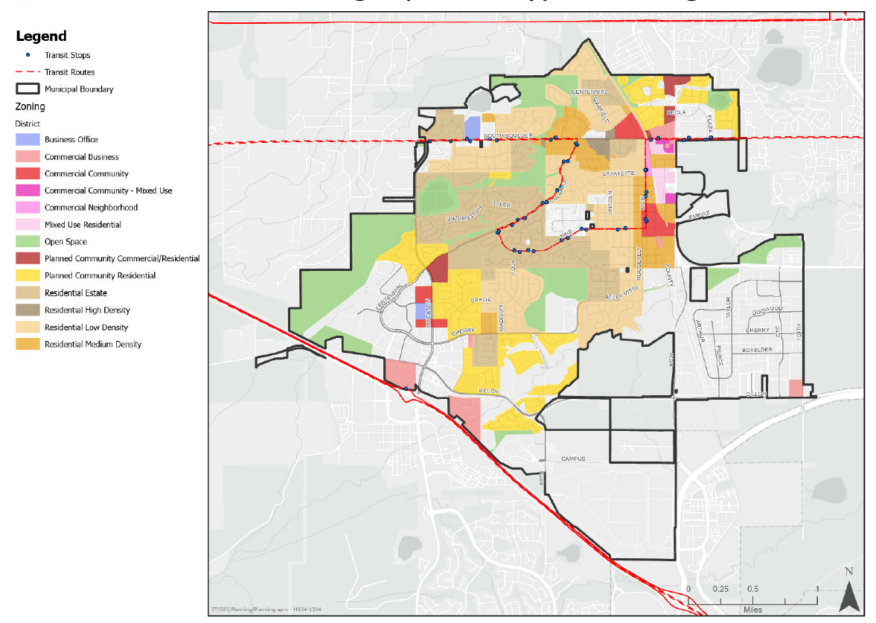
Zoning Districts where Multi-unit and Multifamily are Permitted Uses

Although minimum parking requirements would no longer be enforced, staff anticipate that most new development will continue to include off street parking voluntarily. This expectation is supported by typical market and financing considerations, including lender requirements and long term leasing feasibility, particularly in suburban communities like Louisville. Staff recognize the potential for unintended impacts, such as spillover parking in adjacent neighborhoods or commercial areas, but note that the extent of such effects remains uncertain and will depend on the specific characteristics of future development. Ongoing monitoring will inform any future policy adjustments

2025 COUNCIL WORK PLAN:
This code amendment supports the 2025 City Council Work Plan by addressing two Council Priorities:

- Economic Vitality - this item is a targeted development code amendment to maintain a business-friendly approach by providing more flexibility for site planning with residential and mixed use buildings near transit.

- Housing – this item implements the Housing Plan through a development code amendment that supports more flexibility for off street parking, which can be one of the most significant barriers to building new, more affordable housing.

FISCAL IMPACT:
Budgeted?: Not Applicable

ALTERNATIVES:

The City Council may approve, approve with amendments, or deny the ordinance amendment.

Denial of the ordinance will leave the City in violation of HB24-1304. This may result in loss of eligibility for state funding and create legal challenges for the City.

PUBLIC COMMENTS:

No public comments have been received as of the date of this report.

PLANNINING COMMISSION RECOMMENDATION:
On May 8, 2025, The Planning Commission recommended approval of Resolution 8, Series 2025, approval of an ordinance amending Title 17 of the Louisville Municipal Code (LMC) concerning parking minimums for multifamily and adaptive reuse development to comply with HB24-1304.

Planning Commission did not consider the citywide elimination of parking minimums for multiunit and multifamily uses.

STAFF RECOMMENDATION:
Staff recommend approval of Ordinance 1897, Series 2025, amending Title 17 of the Louisville Municipal Code (LMC) concerning parking minimums for multifamily and adaptive reuse development to comply with HB24-1304.

ATTACHMENTS:
- Ordinance 1897, Series 2025
- July 8, 2025, City Council Packet Link

