PUBLIC NOTICE
CITY OF LOUISVILLE
CITY COUNCIL

NOTICE IS HEREBY GIVEN THAT A PUBLIC HEARING WILL BE HELD BEFORE THE CITY OF LOUISVILLE CITY COUNCIL to consider A request for aN AMENDMENT TO THE LOUISVILLE MUNICIPAL CODE TO ALLOW banquet or reception halls and to consider a special review use to allow for the use group: Banquet or reception hall, for the property at 957 main street

Application Name: | Banquet or Reception Hall Code Amendment and 957 Main Street SRU
Location (SRU) | 957 Main Street; Lot 1, Block 5, Town Of Louisville
Case Number:
  LMCA-0391-2022 AND SRU-0392-2022
Date and Time: | Tuesday, May 3, 2022 at 6:00 PM
Place: | Such hearing will be conducted both at the City of Louisville, 749 Main Street, Louisville, Colorado and Electronically. Members of the public may attend in person or participate electronically in accordance with the policies adopted by the City Council. Notice will be posted at the following website at least seventy-two (72) hours before the meeting with instructions regarding how interested persons may participate in the public hearing: https://www.louisvilleco.gov/local-government/government/city-council/city-council-meeting-agendas-packets-minutes
Persons in any manner interested in the above described application are encouraged to attend the public hearing in person or electronically and/or provide comments by way of the following:

Mail: | Louisville Planning Division  749 Main Street  Louisville, CO 80027
E-Mail: | Planning@louisvilleco.gov

Published in the Daily Camera Sunday, April 17, 2022

Posted in City Hall, Public Library, Recreation Center and the Courts and Police Building on Friday, April 15, 2022.

If you are unable to access materials online and would prefer paper copies or need assistance accessing an electronic meeting please contact the Planning Department at 303-335-4592 or planning@louisvilleco.gov.

To view the application materials, visit: www.louisvilleco.gov/planningapplications

VICINITY MAP

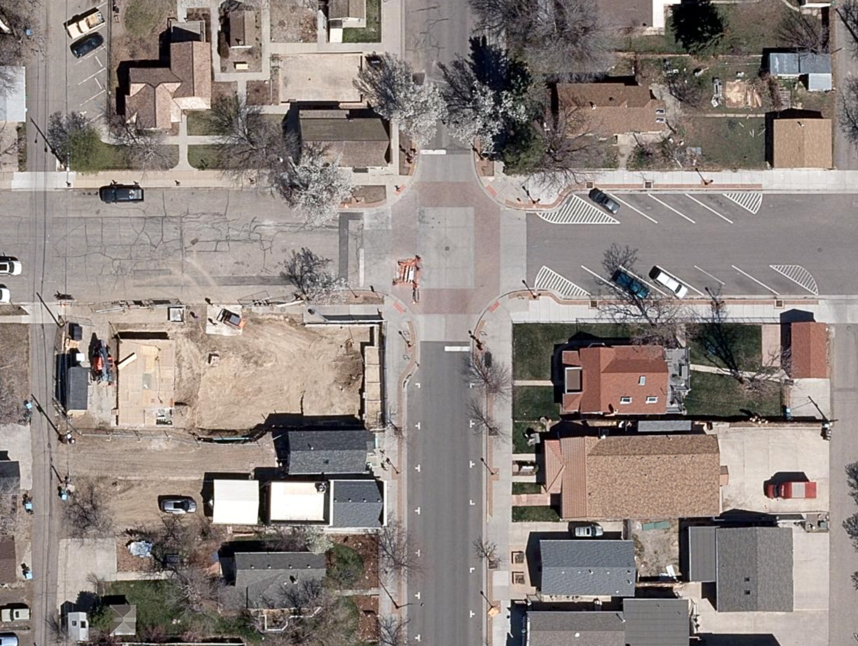
Main Street
South Street

