Additional Information
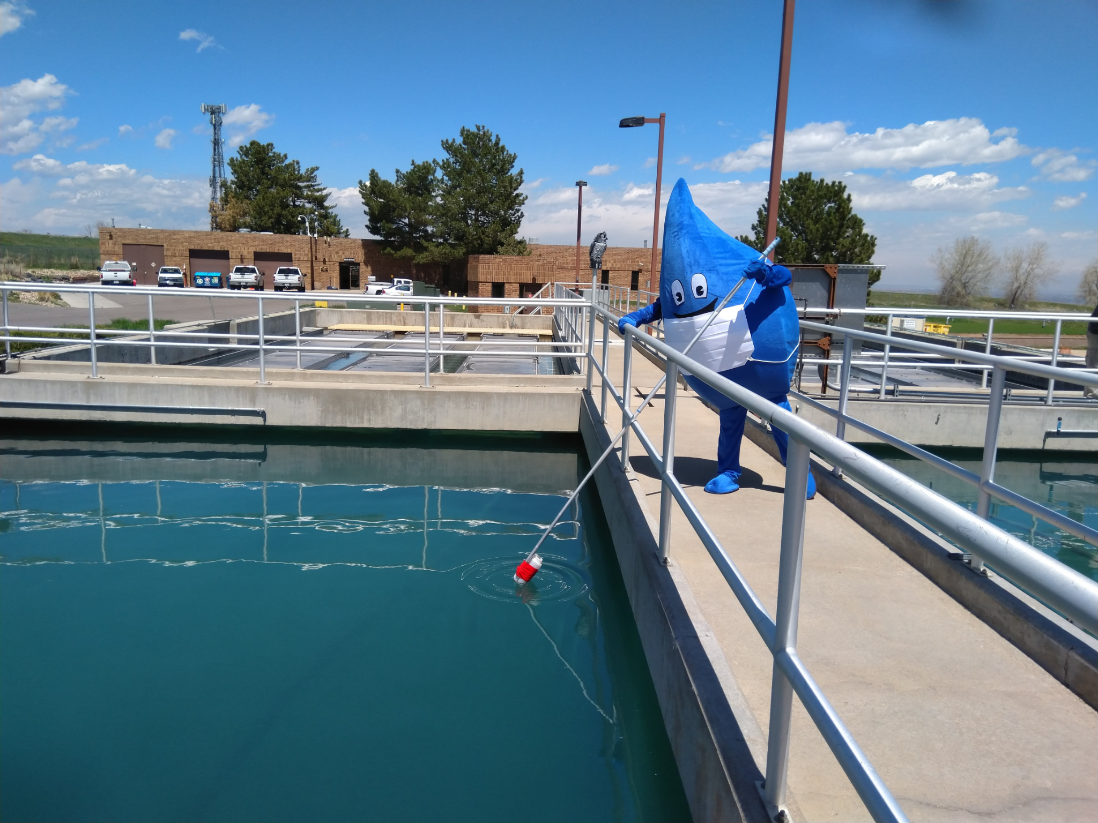

The following sites will give you additional information on water treatment, stream flow, and other water related topics.
- The Environmental Protection Agency homepage's Key Topic List - water, will direct you to EPA information on watersheds, regulations, and educational material.
- The EPA also offers information on water standards and water treatment science at its Drinking Water Health Advisories page.
- The American Water Works Association homepage under Consumer Water Center will answer questions, lead you to sources for information, and give a brief history of drinking water.
- Colorado Stream Flow Data gives access to the flow of state streams and rivers.
- Urban Drainage and Flood Control District's homepage lets you retrieve live weather monitoring information and predicts bad weather and flood warnings for the metro area. Urban Drainage and Flood Control District Brochure
- Colorado Lake and Reservoir Management Association is dedicated to preserving the quality of the lakes and reservoirs around the state.
- On the Water Environment Federation's homepage under Education and Outreach will give you information on the treating of wastewater and protections in place to assure stream and river water quality.
- The Climate Prediction Center gives the monthly or yearly outlook for the United States precipitation and drought situations.
- The Colorado Rural Water Association's homepage gives access to several information sites. Rural water works with small communities to help with operator certification and water or wastewater systems operations.
