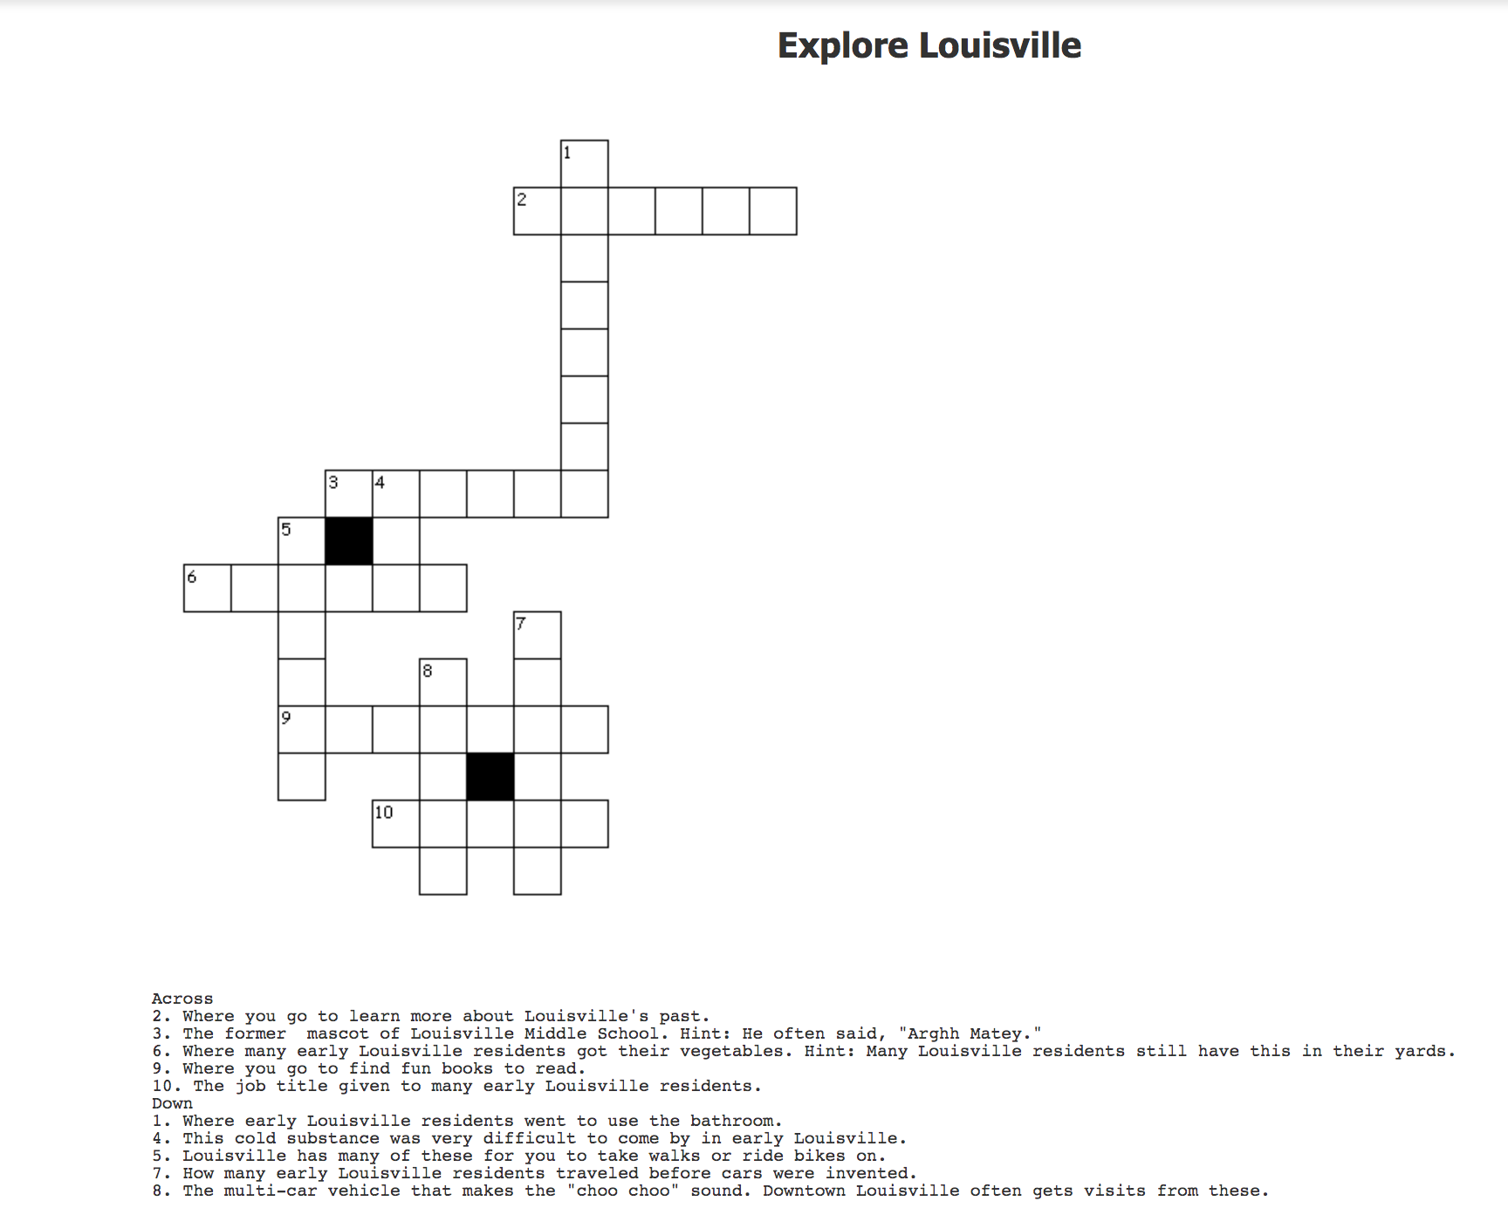
Across:
2. Museum
3. Pirate
6. Garden
9. Library
10. Miner

Down:
1. Outhouse
4. Ice
5. Trials
7. horses
8. Train

Answers
Explore Louisville
A crossword puzzle designed for the whole family.

