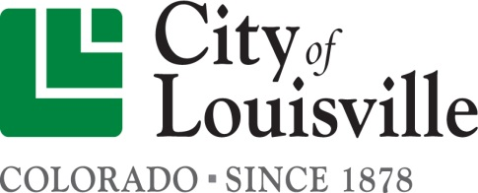
Department of Building Safety Policy and Procedure Statement
FROM: Chad Root, CBO

SUBJECT: Service Panel Upgrades

DATE: January 8, 2018

Purpose: This policy is to give guidance and transparency on what is expected and will be required by the Department of Building and Life Safety when a permit is pulled to upgrade the service panel. By doing a policy it becomes clear what will be expected from homeowner or contractor and what cost are going to be involved with upgrading a service panel.

Policy: For Residential homes when the service panel is the only component of the homes electrical system that is up graded. The Department of Building and Life Safety will not require all the breakers, wiring and outlets to be brought up to current code. In many Cities this is required even though it is not required by code. The Louisville Building Official along with all of its staff members feels this put an undue burden and cost of upgrading what could be considered an unsafe service panel or under rated panel. By installing a new panel that is rated properly for the use and by the department not requiring all the branch circuits to brought to code with ARC fault breakers. The Department feels that doing so meets the intent of the code and the system is that much safer from where it was if they were not to upgrade to a newer and safer panel. For Commercial projects the same policy is in effect though there may be some additional requirements from the field inspector to bring certain circuits up to code due to life safety concerns.

